
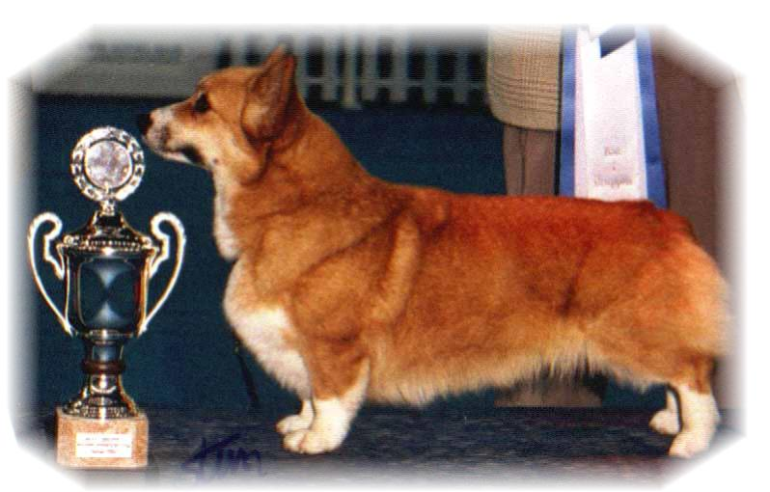

PARENTS |  | GRAND PARENTS |  | GREAT GRAND PARENTS |  | GREAT GREAT GRAND PARENTS
SIRE | EUV16  ANDVOL MARSHAL  RKF4238309 | SIRE | RU.CH  SALVENIK SAIL AWAY | SIRE | ROSEWOOD SET SAIL TO SALVENIK | SIRE | TWINAN ANOTHER CHANCE FOR SALVENIK
 |  |  |  |  |  | DAM | ROSEWOOD BREEZE’N BY
 |  |  |  | DAM | SALVENIK STAR PERFORMER | SIRE | GB.CH TWINAN COSTUM MADE
 |  |  |  |  |  | DAM | SALVENIK STARS IN YOUR EYES
SIRE | EUV16  ANDVOL MARSHAL  RKF4238309 | DAM | CIB.CH  SIGGEN’S QUALITY BLACK PEARL | SIRE | CIB.GB.MULTI CH, WW08.EUW11  ANDVOL YA TVOY KUMIR | SIRE | CIB CH ERMYN CRANBERRY FROST
 |  |  |  |  |  | DAM | ANDVOL KOROLEVA MARGO
 |  |  |  | DAM | CIB.NORD.CH NORDW10.NVW16  SIGGEN’S HAZEL | SIRE | CIB.CH CUUCHIN ASPENGLOW
 |  |  |  |  |  | DAM | CIB.NORD.CH EUW06.WW10.WWV11 SIGGEN’S UPTOWN GIRL
DAM | CIB.NORD:LUX CH NV11 BISS 2GB CC’S  CIMAITH’S ELEGANT SIGGEN DESIGN  NO44686/09 | SIRE | CIB.GB.N.S.CH NW07.SW08  SIGGEN’S DOFFEN | SIRE | CIB.NORD.CH.NW08.10  SIGGEN’S YASSIR | SIRE | SE.EE.CH CRAIGYCOR RUM PUNCH
 |  |  |  |  |  | DAM | N.CH SIGGEN’S ROXY MUSIC
 |  |  |  | DAM | CIB.SE.EE.CH  OTREKS NORTHERN STAR | SIRE | US.CH PENTALAR PRINCE HARRI
 |  |  |  |  |  | DAM | OTREKS FOOLISH DESIGN
DAM |  | DAM | CIB.AUS.S.CH WW08  CUUCHIN BORN TO ENCHANT | SIRE | AUS.CH  CUUCHIN SUPERSTAR | SIRE | AUS.CH ABERLEE STAR SEQUENCE
 |  |  |  |  |  | DAM | KEVLAIN KRISTA
 |  |  |  | DAM | AUS.CH  CUUCHIN BORN T BEWITCH | SIRE | AUS.CH CUUCHIN BORN T PERFORM
 |  |  |  |  |  | DAM | AUS.CH ANTUDOR BEWITCHED

PEDIGREE OF : | Siggen’s E-kull |  | COLOUR AND MARKINGS :
DATE OF BIRTH : | 02012017 |  | SEX :
Rita & Leif Herman Wilberg
Blåkollstubben 27, PB : 144
1921 Sørumsand, NORWAY
Tlf : +47 97027566, +47 90084320, +47 97763827
Email : leif.herman@wilberg.info rita@wilberg.info julie_wilberg@hotmail.com
www.kennelsiggen.com

