
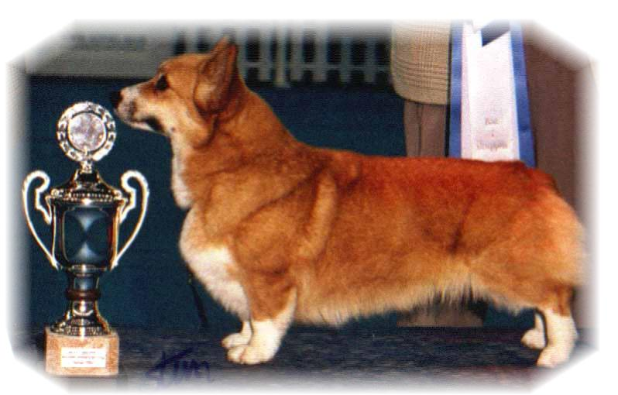

PARENTS |  | GRAND PARENTS |  | GREAT GRAND PARENTS |  | GREAT GREAT GRAND PARENTS
SIRE | CIB.NORD.EE.RUS EUW15  ANNLINE’S MY WAYS CHANCE  FIN 37325/05 | SIRE | SE.EE CH  CRAIGYCOR RUM PUNCH | SIRE | USA.CH  TALLYRAND NO GREATER LOVE | SIRE | USA CH LLANDIANS SWEET SUCCESS
 |  |  |  |  |  | DAM | USA CH ROM TALLYRAND AMAZING LOVE
 |  |  |  | DAM | IRL CH  SHAVALS FIRE VISION AT CRAIGYCOR | SIRE | USA.GB CH ROMX NINACORTE STAR CASTER AT WOODHENGE
 |  |  |  |  |  | DAM | GB CH SHAVALS FIRE ODYSSEY
SIRE |  | DAM | FIN CH  DWYNELLA KIWI CHANCE FOR ANNLINES | SIRE | NZ CH  DWYNELLA PRICE CHARMER | SIRE | CH BELROYD EMPEROR
 |  |  |  |  |  | DAM | NZ CH DWYNELLA ADICT’D TO LOVE
 |  |  |  | DAM | NZ CH  DWYNELLA LOVE N‘CHANCE | SIRE | GB.NZ CH SALVENIK SUPER CHANCE
 |  |  |  |  |  | DAM | NZ CH DWYNELLA ADICT’D TO LOVE
DAM | INT.NORD.CH  SIGGEN’S STELLA POLARIS  NO42903/13 | SIRE | USA GCH  TALLYRAND HALO CHASER | SIRE | USA.CH  ABERLEE BRANDSBY | SIRE | AUS.CH VLANDY SILVER PHANTOM
 |  |  |  |  |  | DAM | ABERLEE KIGA
 |  |  |  | DAM | TALLYRAND DEVOTED TO YOU | SIRE | USA.CH TALLYRAND ARCHANGEL MICHAEL
 |  |  |  |  |  | DAM | TALLYRAND CONSIER THE LILLIES
DAM | INT.NORD.CH  SIGGEN’S STELLA POLARIS  NO42903/13 | DAM | INT.NORD CH.NORDV11  SIGGEN’S HAZEL | SIRE | SE.EE.CH  CUUCHIN ASPENGLOW | SIRE | BELROYD DRAGONFLY
 |  |  |  |  |  | DAM | PEMLAND LADY OF NIGHT
 |  |  |  | DAM | INT.NORD.CH VWW 10  SIGGEN’S UPTOWN GIRL | SIRE | NORD.CH PEMLAND MOONLIGHT
 |  |  |  |  |  | DAM | INT.NORD.CH SIGGEN’S JESSIKA

PEDIGREE OF : | Siggen’s A-kull 15 |  | COLOUR AND MARKINGS :
DATE OF BIRTH : | 25.11.2015 |  | SEX :
Rita & Leif Herman Wilberg, Julie Wilberg Brandvik
Blåkollstubben 27, PB : 144
1921 Sørumsand, NORWAY
Tlf : +47 97027566, +47 90084320, +47 97763827
Email : leif.herman@wilberg.info rita@wilberg.info
www.kennelsiggen.com

