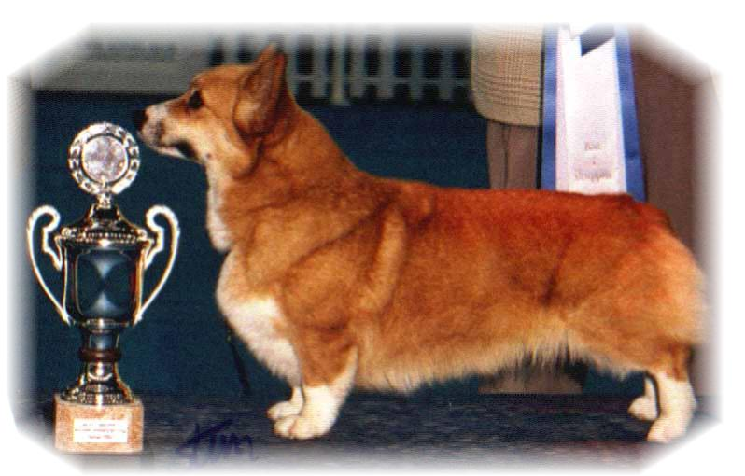

|  |  |  |  |  |  |  |  |
| --- | --- | --- | --- | --- | --- | --- | --- |
| PARENTS | | GRAND PARENTS | | GREAT GRAND PARENTS | | GREAT GREAT GRAND PARENTS | |
| SIRE | ANVOL MARSHAL  RKF 4238309 | SIRE | RUS CH  SALVENIK SAIL AWAY | SIRE | GB CH  ROSEWOOD SET SAIL TO SALVENIK | SIRE | USA CH TWINAN ANOTHER CHANCE FOR SALVENIK |
| DAM | USA CH ROSEWOOD BREEZE N BY |
| DAM | SALVENIK STAR PERFORMER | SIRE | GB CH TWINAN CUSTOM MADE |
| DAM | SALVENIK STARS IN YOUR EYES |
| DAM | CIB,RUS.CH  SIGGEN’S QUALITY BLACK PEARL | SIRE | WW08EW11INT.GB.MULTI.CH.  ANDVOL YA TVOY KUMIR | SIRE | INT CH ERMYN CRANBERRY FROST |
| DAM | INT.RUS CH ANDVOL KOROLEVA MARGO |
| DAM | INT.NORD CH NORDV10  SIGGEN’S HAZEL | SIRE | INT.AUS.SE.EE CH CUUCHIN ASPENGLOW |
| DAM | INT.NORD CH WVW10 SIGGEN’S UPTOWN GIRL |
| DAM | INT.NORD.LUX.NL.BE CH.  SIGGEN’S MARGUERITA  NO 44151/11 | SIRE | INT.GB.NO.SE.CH.NV07.SV08  SIGGEN’S DOFFEN | SIRE | US.INT.NORD.U.CH.  NV-08,NV-10  SIGGEN’S YASSIR | SIRE | INT.CH CRAIGYCOR RUM PUNCH |
| DAM | NO.SE.CH SIGGEN’S ROXY MUSIC |
| DAM | FRW-12. INT.SE.EE.U.CH. OTREKS NORTHERN STAR | SIRE | US.CH PENTALAR PRINCE HARRI |
| DAM | OTREKS FOOLISH DESIGN |
| DAM | INT.NORD CH NORDV10  SIGGEN’S HAZEL | SIRE | INT.AUS.SE.EE CH  CUUCHIN ASPENGLOW | SIRE | AUST CH CUUCHIN LOTZA PIAZZ |
| DAM | CUUCHIN GOLD SEQUINS |
| DAM | INT.NORD CH.WVW11  SIGGEN’S UPTOWN GIRL | SIRE | NORD CH PEMLAND MOONLIGHT |
| DAM | INT.NORD CH SIGGEN’S JESSIKA |

|  |  |  |  |  |
| --- | --- | --- | --- | --- |
| PEDIGREE OF : | Siggen’s B-kull |  | COLOUR AND MARKINGS : | Tricolor |
| DATE OF BIRTH : | 16.05.2016 |  | SEX : | Male |

Rita & Leif Herman Wilberg

Blåkollstubben 27, PB : 144

1921 Sørumsand, Norway

Tlf : +47 97027566, +4790084320

Email:rita@wilberg.info leif.herman@wilberg.info