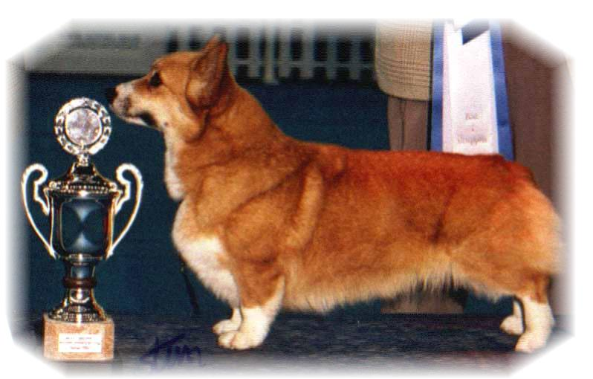

PARENTS |  | GRAND PARENTS |  | GREAT GRAND PARENTS |  | GREAT GREAT GRAND PARENTS
SIRE | GB.CH MULTI BISS  PEMCADER THUNDERBALL | SIRE | GB.CH  PEMCADER BELROYD ZEUS | SIRE | GB.NZ.CH  SALVENIK SUPER CHANCE | SIRE | GB.CH SUPER GUY OF PEMLAND
 |  |  |  |  |  | DAM | GB.CH  KILVEWOOD ODE TO JOY OF SALVENIK
 |  |  |  | DAM | BELROYD ORANGE FEATHER | SIRE | BELROYD MONEY SPINNER
 |  |  |  |  |  | DAM | BELROYD ICE DANCER
SIRE | GB.CH MULTI BISS  PEMCADER THUNDERBALL | DAM | PEMCADER BLACK GLAMOUR | SIRE | GB.CIB.NO.SE.CH NW07.SW08  SIGGEN’S DOFFEN | SIRE | US.CIB.NORD.CH NW08-10  SIGGEN’S YASSIR
 |  |  |  |  |  | DAM | CIB.SE.EE.CH FW12  OTREKS NORTHERN STAR
 |  |  |  | DAM | NZ.CH  DWYNELLA ALL THAT JAZZ | SIRE | US.NZ.CH ROM  DWYNELLA ROYAL FOOTMAN
 |  |  |  |  |  | DAM | DWYNELLA GOLD JAZZ
DAM | CIB.NORD.CH MULTI BISS. KBHW13  SIGGEN’S QUEEN OF DIAMONDS | SIRE | CIB.GB.MULTI.CH WW08.EUW11  ANDVOL YA TVOY KUMIR | SIRE | CIB.RUS.CH  ERMYN CRANBERRY FROST | SIRE | GB CH ERMYN WING AND A PRAYER
 |  |  |  |  |  | DAM | JANJINKS NOONDAY STAR AT ERMYN
 |  |  |  | DAM | CIB.RUS.UA.CH  ANDVOL KOROLEVA MARGO | SIRE | RUS.CH ANDVOL ZOLOTOY OSCAR
 |  |  |  |  |  | DAM | ANDVOL EMILI
DAM | CIB.NORD.CH MULTI BISS. KBHW13  SIGGEN’S QUEEN OF DIAMONDS | DAM | CIB.NORD.CH BISS NORDW10.DKW11  SIGGEN’S HAZEL | SIRE | CIB.SE.EE CH  CUUCHIN ASPENGLOW | SIRE | AUS.CH CUUCHIN LOTZA PIZAZZ
 |  |  |  |  |  | DAM | AUS.CH CUUCHIN GOLD SEQUINS
 |  |  |  | DAM | CIB.NORD.CH WW10.WWV11. EUW06.NV04.SW05.NORDW11.  NORDWV11.NWV11.12  SIGGEN’S UPTOWN GIRL | SIRE | NORD.CH PEMLAND MOONLIGHT
 |  |  |  |  |  | DAM | CIB.NORD.CH SIGGEN’S JESSIKA

PEDIGREE OF : | Siggen’s F-kull |  | COLOUR AND MARKINGS : | Red/white
DATE OF BIRTH : | 04.03.2017 |  | SEX : | Male

Rita & Leif Herman Wilberg
Blåkollstubben 27, PB : 144
1921 Sørumsand, NORWAY
Tlf : +47 97027566, +47 90084320, +47 97763827
Email : leif.herman@wilberg.info rita@wilberg.info julie_wilberg@hotmail.com
www.kennelsiggen.com

