
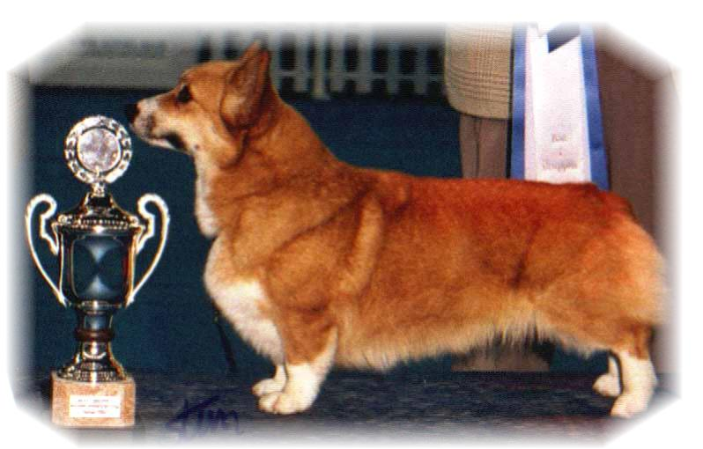

PARENTS |  | GRAND PARENTS |  | GREAT GRAND PARENTS |  | GREAT GREAT GRAND PARENTS
SIRE | WW-13, MULTI CH  ANDVOL MERCURY  RKF2840284 | SIRE | RU LT CH  KINSALE STAR TREAT | SIRE | US UAR CH  LLANDIANS STORM CATCHER | SIRE | ROMX US CH ABERLEE STORM FORCE
 |  |  |  |  |  | DAM | POWDERMILL SWEET GOLD
 |  |  |  | DAM | UAR CH  KINSALE MIDNIGHT MAGIC | SIRE | UAR CH ABERLEE FOXYTALE OF HIGHLEE
 |  |  |  |  |  | DAM | HIGHLEE KIRI BEAR OF VON WINDECKE
SIRE | WW-13, MULTI CH  ANDVOL MERCURY  RKF2840284 | DAM | INT.RU,LT,FI,UA,HR CH  ANDVOL NINA RICCI | SIRE | RU,SK CK  TWINAN GOLD SOVEREIGN | SIRE | HIGHWORTH PRECISION MADE
 |  |  |  |  |  | DAM | TWINAN THE STONE MAIDEN
 |  |  |  | DAM | ANFISA HAUS DANDO | SIRE | RU CH ANDVOL ZOLOTOY OSCAR
 |  |  |  |  |  | DAM | BARABAKA DJENESTRA
DAM | N CH  SIGGEN’S SPRING FLING  NO42902/13 | SIRE | US GR CH  TALLYRAND HALO CHASER | SIRE | US CH  ABERLEE BRANDSBY | SIRE | BISS US CH VLANDYN SILVER PHANTOM
 |  |  |  |  |  | DAM | ABERLEE KIGA
 |  |  |  | DAM | TALLYRAND DEVOTED TO YOU | SIRE | US CH TALLYRAND ARCHANGEL MICHAEL
 |  |  |  |  |  | DAM | TALLYRAND CONSIER THE LILLIES
DAM | N CH  SIGGEN’S SPRING FLING  NO42902/13 | DAM | INT.NORD. CH NORD V 10, NVV 16  SIGGEN’S HAZEL | SIRE | INT.AUS.SE.EE CH  CUUCHIN ASPENGLOW | SIRE | AUS CH  CUUCHIN LOTZA PIZAZZ
 |  |  |  |  |  | DAM | CUUCHIN GOLD SEQUINS
 |  |  |  | DAM | INT.NORD.FI CH WW10.WWV11 EUW06..NV04.NVV11.SVO4.05.NVV1,12  SIGGEN‘S UPTOWN GIRL | SIRE | NORD CH  PEMLAND MOONLIGHT
 |  |  |  |  |  | DAM | INT.NORD.CH  SIGGEN’S JESSIKA

PEDIGREE OF : | Siggen’s G-kull |  | COLOUR AND MARKINGS :
DATE OF BIRTH : | 11.04.2017 |  | SEX :
Rita & Leif Herman Wilberg
Blåkollstubben 27, PB : 144
1921 Sørumsand, NORWAY
Tlf : +47 97027566, +47 90084320, +47 97763827
Email : leif.herman@wilberg.info rita@wilberg.info julie_wilberg@hotmail.com
www.kennelsiggen.com

