
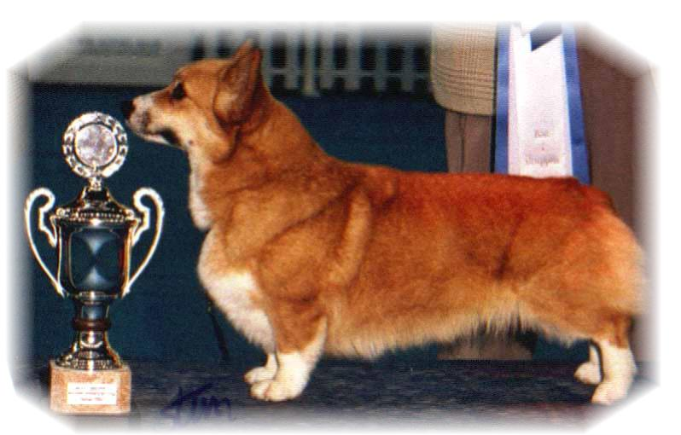

PARENTS |  | GRAND PARENTS |  | GREAT GRAND PARENTS |  | GREAT GREAT GRAND PARENTS
SIRE | WW09.US.INT.EE.SE.SK. CH  NEBRIOWA COLE HAAN | SIRE | US. CH  FERGWYN NEW VOYAGER | SIRE | FERGWYN CAPTAIN FANTASY | SIRE | AUS.CH DWYNELLA ROYAL FOOTMAN
 |  |  |  |  |  | DAM | FERGWYN MODESTY BLAZE
 |  |  |  | DAM | AUS.CH FERGWYN CHANCE ENCOUNTER | SIRE | JOPEARL MANHATTAN MOON
 |  |  |  |  |  | DAM | FERGWYN COCO CHANEL
SIRE | WW09.US.INT.EE.SE.SK. CH  NEBRIOWA COLE HAAN | DAM | US.CH  NEBIROWA HELLO GOOD LOOKIN | SIRE | US.CH BISS ROMX  HUM’NBIRD VALEDICTORIAN | SIRE | US.CH LARCHMONTS HUM’NBIRD HUM
 |  |  |  |  |  | DAM | US.CH BEUKAYS DOUBLE DELIGHT
 |  |  |  | DAM | US.CH  NEBRIOWA CHINA DOVE | SIRE | US.CH ROM  NEBRIOWA FRONT AND CENTER
 |  |  |  |  |  | DAM | US.CH BELROYD DOVEKIE
DAM | INT.NORD.FI.PH.CH BISS  SIGGEN’S SWEET SENSATION | SIRE | ROM.US.GRAND.CH BISS  TALLYRAND HALO CHASER | SIRE | US.CH  ABERLEE BRANDSBY | SIRE | AUS.CH VLANDYN SILVER PHANTOM
 |  |  |  |  |  | DAM | ABERLEE KIGA
 |  |  |  | DAM | TALLYRAND DEVOTED TO YOU | SIRE | US.CH  TALLYRAND ARCHANGEL MICHAEL
 |  |  |  |  |  | DAM | US.CH  TALLYRAND CONSIDER THE LILIES
DAM | INT.NORD.FI.PH.CH BISS  SIGGEN’S SWEET SENSATION | DAM | INT.NORD.CH NORDV-10 BISS  SIGGEN’S HAZEL | SIRE | INT.AUS.SE.EE.CH  CUUCHIN ASPENGLOW | SIRE | AUS.CH  CUUCHIN LOTZA PIZAZZ
 |  |  |  |  |  | DAM | CUUCHIN GOLD SEQUINS
 |  |  |  | DAM | WW-10,WWV-11. INT. NORD.SF.CH NV-04.SV-04,05. EUV-06 MULTI BISS  SIGGEN’S UPTOWN GIRL | SIRE | NORD.CH BISS  PEMLAND MOONLIGHT
 |  |  |  |  |  | DAM | INT.NORD.CH  SIGGEN’S JESSIKA
PEDIGREE OF : | Siggen’s Z -kull |  | COLOUR AND MARKINGS :
DATE OF BIRTH : | 01.08.2015 |  | SEX :
Rita & Leif Herman Wilberg
Blåkollstubben 27, PB : 144
1921 Sørumsand, NORWAY
Tlf : +47 97027566, +47 90084320, +47 97763827
Email : leif.herman@wilberg.info rita@wilberg.info julie_wilberg@hotmail.com
www.kennelsiggen.com

