
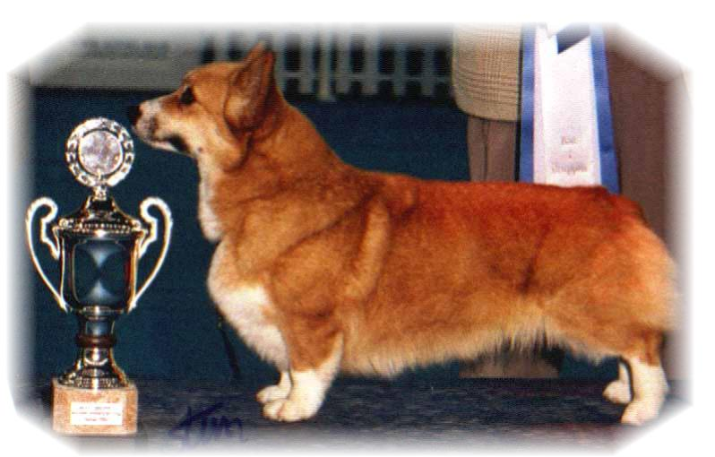

PARENTS |  | GRAND PARENTS |  | GREAT GRAND PARENTS |  | GREAT GREAT GRAND PARENTS
SIRE | Int.AUST.S.ESTch  Cuuchin Aspenglow  ANKCSB 4100097678 | SIRE | Aust.ch  Cuuchin Lotza Pizazz | SIRE | Aust.ch  Antudor Lucky Star | SIRE | Aust.ch Aberlee Star Sequence
 |  |  |  |  |  | DAM | Aust. ch Antudor Champayne Magic
 |  |  |  | DAM | Aust.ch  Cuuchin Charisma | SIRE | Aust.ch Cuuchin Ace Ospades
 |  |  |  |  |  | DAM | Cuuchin Maid To March
SIRE | Int.AUST.S.ESTch  Cuuchin Aspenglow  ANKCSB 4100097678 | DAM | Cuuchin Gold Sequins | SIRE | Aust.ch  Aberlee Star Sequence | SIRE | Aust. ch Jodiwyn Royal Warrior
 |  |  |  |  |  | DAM | Aust.ch Aberlee Catch Astar
 |  |  |  | DAM | Cuuchin Gold Dust | SIRE | Aust.ch Welcornel Classic Magic
 |  |  |  |  |  | DAM | Aust.ch Cuuchin Go For Gold
DAM | Int. Nord.N.S.DK. Finsk.U.Ch.NV-04, SV-04,05. EUV-06  Siggen’s Uptown Girl  22310/02 | SIRE | Nord.ch  Pemland Moonlight | SIRE | Belroyd Dragonfly | SIRE | GB.ch Cordach Tribune
 |  |  |  |  |  | DAM | Belroyd Wood Chat
 |  |  |  | DAM | Pemland Lady of Night | SIRE | GB.ch  Bannalyne Royal Edition of Rivaona
 |  |  |  |  |  | DAM | Fitzdown Misty Coral of Pemland
DAM |  | DAM | Int. Nord.ch  Siggen’s Jessika | SIRE | N.ch Stompen’s Herman | SIRE | Int.Nord.ch Blands Gamblin’ Man
 |  |  |  |  |  | DAM | Malsis Sweet Girl
 |  |  |  | DAM | Int.Nord.ch NV91,92,97,99,  SV93,94,EuV97, KbHV97BrV95  Siggen’s Conny | SIRE | Kaytop Dream of Delight
 |  |  |  |  |  | DAM | Int.N.S.ch NV90  Siggen’s Victoria
PEDIGREE OF : | Siggen’s H-kull |  | COLOUR AND MARKINGS : | Rød og hvit
DATE OF BIRTH : | 02.05.2008 |  | SEX : | Han
Rita & Leif Herman Wilberg
Blåkollstubben 27, PB : 158
1921 Sørumsand
Tlf : +47 63 82 61 17 (Private)
Fax : +47 63 82 70 89
Email : kesiggen@online.no
www.kennelsiggen.com

