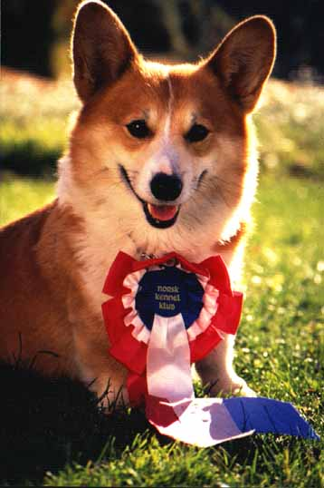
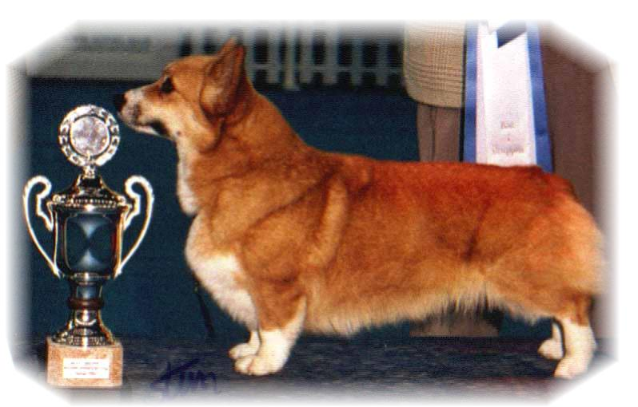

PARENTS |  | GRAND PARENTS |  | GREAT GRAND PARENTS |  | GREAT GREAT GRAND PARENTS
SIRE | CIB.NORD CH  SIGGEN’S PUSJKIN  NO40131/12 | SIRE | CIB.GB MULTI CH WW08. EUW11  ANDVOL YA TVOY KUMIR | SIRE | RUS.UKR.MOL CH  ERMYN CRANBERRY FROST | SIRE | GB CH ERMYN WING AND PRAYER
 |  |  |  |  |  | DAM | JANJINKS NOONDAY STAR AT ERMYN
 |  |  |  | DAM | ANDVOL KOROLEVA MARGO | SIRE | RUS CH ANDVOL ZOLOTOY OSCAR
 |  |  |  |  |  | DAM | ANDVOL EMILI
SIRE | CIB.NORD CH  SIGGEN’S PUSJKIN  NO40131/12 | DAM | NO CH  SIGGEN’S JOZZE FINFIN | SIRE | INT.US.SE.EE CH WW09  NEBRIOWA COLE HAAN | SIRE | US CH FERGWYN NOW VOYAGER
 |  |  |  |  |  | DAM | US CH NEBRIOWA HELLO GOOD LOOKIN
 |  |  |  | DAM | NO.SE CH SIGGEN’S ELLE VILLE | SIRE | SE CH SIGGEN’S DOOLEY
 |  |  |  |  |  | DAM | INT-NORD.CH WW10.WWV11.EUW06.NW04.SW 04.05  SIGGEN’S UPTOWN GIRL
DAM | NORD. AUS SUPREME CH NORDW17.NOW17.DKW17  BOJOJAMILE BEHIND THE NEWS  ANKC2100415767 | SIRE | AUS SUPREME CH  BOJOJAMILE BEAN SERIOUS | SIRE | US CAN CH  STONECROFT’S SECOND SIGHT | SIRE | US CH RENEFIELD SPORT COAT
 |  |  |  |  |  | DAM | CAN CH STONECROFT’S SIMPLY SMITTEN
 |  |  |  | DAM | AUS CH  BOJOJAMILE BIVIAN LEIGH | SIRE | AUS CH CORDACH SENATOR
 |  |  |  |  |  | DAM | AUS CH BOJOJAMILE BRESCIA LEIGH
DAM |  | DAM | AUS CH  BOJOJAMILE BEHIND CLOSED DOORS | SIRE | AUS CH  BOJOJAMILE BORN TO BE WILD | SIRE | AUS SUPREME CH DWYNELLA CAUGHT YOU LOOKING
 |  |  |  |  |  | DAM | AUS CH BOJOJAMILE BEAM OF LIGHT
 |  |  |  | DAM | AUS CH  BOJOJAMILE BEHIND THE SCENES | SIRE | AUS CH BOJOJAMILE BRING IT ON
 |  |  |  |  |  | DAM | AUS CH BOJOJAMILE BRUSHES QUEST

Rita & Leif Herman Wilberg, Julie Wilberg Brandvik
Blåkollstubben 27,21, PB : 144
1921 Sørumsand, NORWAY
Tlf : +47 97027566, +47 90084320, +47 97763827
Email : leif.herman@wilberg.info rita@wilberg.info julie_wilberg@hotmail.com
www.kennelsiggen.com

PEDIGREE OF: SIGGEN’S I-kull COLOUR, MARKINGS, TAILS: H:
DATE OF BIRTH: SEX:

