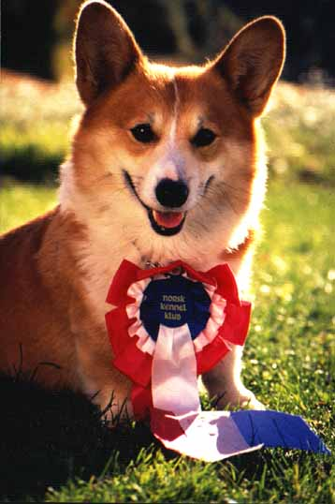
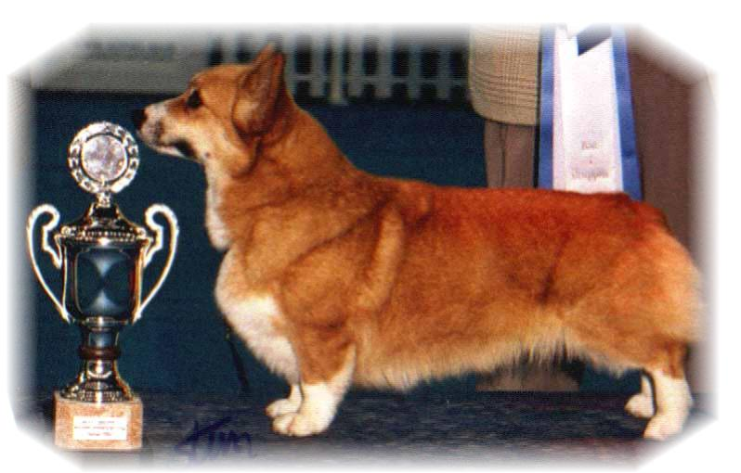

PARENTS |  | GRAND PARENTS |  | GREAT GRAND PARENTS |  | GREAT GREAT GRAND PARENTS
SIRE | WW09,US.S.EST.SKCh Nebriowa Cole Haan | SIRE | US Ch  Fergwyn Now Voyager | SIRE | Fregwyn Captain Fantasy | SIRE | Aust NZ Ch Dwynella Royale Footman
 |  |  |  |  |  | DAM | Fergwyn Modesty Blase
 |  |  |  | DAM | Fergwyn Chance Encounther | SIRE | Jopearl Manhattan Pearl
 |  |  |  |  |  | DAM | Fergwyn Coco Chanel
SIRE | WW09,US.S.EST.SKCh Nebriowa Cole Haan | DAM | US Ch  Nebriowa Hello Good Lookin | SIRE | US Ch  Hum'nbird Valedictorian | SIRE | USCh Larchmon's Hum'n Bird Hum
 |  |  |  |  |  | DAM | US Ch Beaukays Double Delight
 |  |  |  | DAM | US Ch  Nebriowa China Dove | SIRE | US Ch Nebriowa Front and Center
 |  |  |  |  |  | DAM | US Ch Belroyd Doveke
DAM | Siggen's Elle Ville | SIRE | S.N Ch  Siggen's Dooley | SIRE | US.Int.Nord.Ch NV08  Siggen´s Yassir | SIRE | Est Ch.Craigycor Rum Punch
 |  |  |  |  |  | DAM | N.S Ch Siggen's Roxy Music
 |  |  |  | DAM | Ch Otrek's Northern Star | SIRE | US Ch Pentalar Prince Harri
 |  |  |  |  |  | DAM | Ch Otreks Foolish Design
DAM | Siggen's Elle Ville | DAM | Int.Nord.FIN Ch NV04.Sv04,05, EUV06  Siggen's Uptown Girl | SIRE | Nord Ch  Pemland Moonlight | SIRE | Belroyd Dragonfly
 |  |  |  |  |  | DAM | Pemland Lady Of Night
 |  |  |  | DAM | Int.Nord  Ch Siggens Jessika | SIRE | N.S Ch Stompens Herman
 |  |  |  |  |  | DAM | Int.Nord.ch NV91,92,97,99, SV93,94, EUV97  Siggen’s Conny
PEDIGREE OF : | SIGGEN’S J 09 KULL |  | COLOUR AND MARKINGS : | 8 R/V + 1 Tri
DATE OF BIRTH : | 09.07.2009 |  | SEX : | 2 + 7
Rita & Leif Herman Wilberg
Blåkollstubben 27, PB : 144
1921 Sørumsand
Tlf : +47 63 82 61 17 (Private)
Fax : +47 63 82 70 89
Email : kesiggen@online.no
www.kennelsiggen.com

