
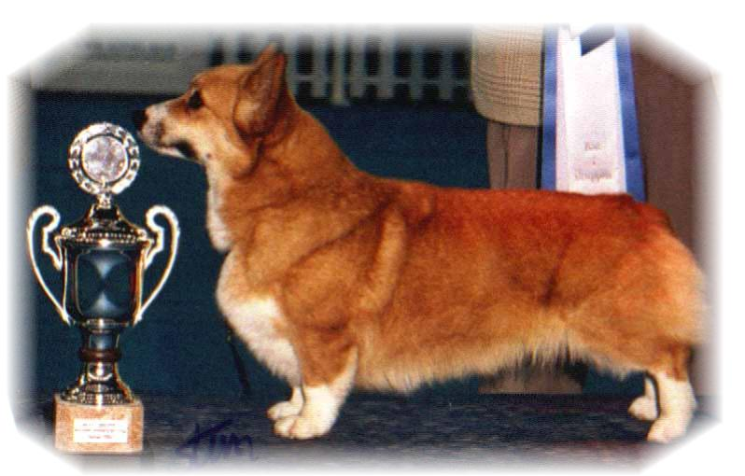

PARENTS |  | GRAND PARENTS |  | GREAT GRAND PARENTS |  | GREAT GREAT GRAND PARENTS
SIRE | NORDW18. NO.SE.CH BISS  SIGGEN-S GREAT GATSBY | SIRE | BISS.WW.EW. MULTI.CH  ANDVOL MERCURY | SIRE | RUS.LT.CH  KINSALE STAR TREAT | SIRE | US.UAR.CH LLANDIN’S STORM CATCHER
 |  |  |  |  |  | DAM | UAR.CH KINSALE MIDNIGHT MAGIC
 |  |  |  | DAM | EW.INT.MULTI CH  ANDVOL NINA RICCI | SIRE | MULTI CH TWINAN GOLD SOVEREIGN
 |  |  |  |  |  | DAM | ANFISA HAUS DANDO
SIRE | NORDW18. NO.SE.CH BISS  SIGGEN-S GREAT GATSBY | DAM | NO.SE.CH  SIGGEN’S SPRING FLING | SIRE | BISS US.GR.CH  TALLYRAND HALO CHASER | SIRE | US.CH ABERLEE BRANDSBY
 |  |  |  |  |  | DAM | TALLYRAND DEVOTED TO YOU
 |  |  |  | DAM | BISS.INT.NORD CH  SIGGEN’S HAZEL | SIRE | AUS.INT.SE.EE.CH CUUCHIN ASPENGLOW
 |  |  |  |  |  | DAM | MULTI.BISS.WW.EW..MULTI.W.INT.NORD.CH  SIGGEN’S UPTOWN GIRL
DAM | INT.NORD.CH.MULTI BISS KBHW13, NW15  SIGGEN’S QUEEN OF DIAMONDS | SIRE | MULTI BISS.WW.EW.INT.GB.  MULTI CH  ANDVOL YA TVOY KUMIR | SIRE | INT.CH  ERMYN CRANBERRY FROST | SIRE | GB.CH ERMYN WING AND A PRAYER
 |  |  |  |  |  | DAM | JANJINKS NOONDAY STAR AT ERMYN
 |  |  |  | DAM | INT.RUS.UA.  ANDVOL KOROLEVA MARGO | SIRE | RUS.CH ANDVOL ZOLOTOY OSCAR
 |  |  |  |  |  | DAM | ANDVOL EMILI
DAM |  | DAM | BISS.INT.NORD.CH  SIGGEN’S HAZEL | SIRE | AUS.INT.SE.EE.CH  CUUCHIN ASPENGLOW | SIRE | CUUCHIN LOTZA PIZZAZZ
 |  |  |  |  |  | DAM | AUS.CH CUUCHIN GOLD SEQUINS
 |  |  |  | DAM | MULTI. BISS.WW.EW.  MULTI.W.INT.MULTI CH  SIGGEN’S UPTOWN GIRL | SIRE | BISS.NORD.CH PEMLAND MOONLIGHT
 |  |  |  |  |  | DAM | INT.NORD.CH SIGGEN’S JESSIKA

Rita & Leif Herman Wilberg, Julie Wilberg Brandvik
Blåkollstubben 27,21, PB : 144
1921 Sørumsand, NORWAY
Tlf : +47 97027566, +47 90084320, +47 97763827
Email : leif.herman@wilberg.info rita@wilberg.info julie_wilberg@hotmail.com
www.kennelsiggen.com

PEDIGREE OF: SIGGEN’S: K-kull COLOUR, MARKINGS, TAILS: H:
DATE OF BIRTH: 09.09.2018 SEX:

