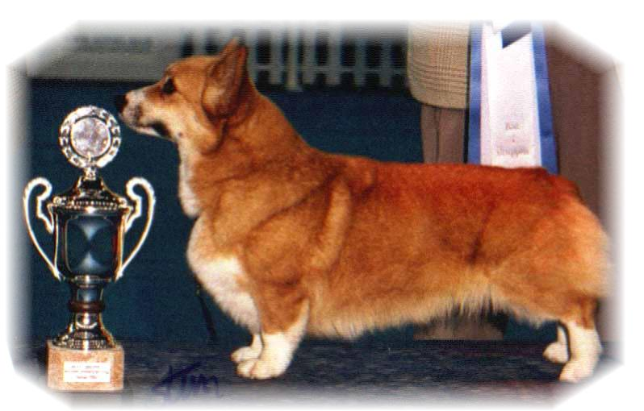

PARENTS |  | KINSALE GRAND PARENTS |  | GREAT GRAND PARENTS |  | GREAT GREAT GRAND PARENTS
SIRE | NORDW-18, N. SE.U.CH. BISS  SIGGEN’S GREAT GATSBY | SIRE | INT.MULTI CH WW10  BISS  ANDVOL MERCURY | SIRE | RU.LT CH  STAR TREAT | SIRE | US CH LLANDIAN STORM CATCHER
 |  |  |  |  |  | DAM | CH KINSALE MIDNIGHT MAGIC
 |  |  |  | DAM | INT.MULTI CH  ANDVOL NINA RICCI | SIRE | RU.SK CH TWINAN GOLD SOVEREIGN
 |  |  |  |  |  | DAM | ANFISS HSUS DANDO
SIRE | NORDW-18, N. SE.U.CH. BISS  SIGGEN’S GREAT GATSBY | DAM | NO CH  SIGGEN’S SPRING FLING | SIRE | US GR CH BISS  TALLYRAND HALO CHASER | SIRE | US CH ABERLEE BRANDSBY
 |  |  |  |  |  | DAM | TALLYRAND DEVOTED TO YOU
 |  |  |  | DAM | INT.NORD CH NORDV10,NVV16  SIGGEN’S HAZEL | SIRE | INT.AUS.SE.EE CH CUUCHIN ASPEN GLOW
 |  |  |  |  |  | DAM | INT.NORD CH NV4,NVV11 SIGGEN’S UPTOWN GIRL
DAM | GB. INT.NORD.HR CH.WW-17, JWW-13. DKV-13, 14. SEV-13,14. NV-14.NORDV-14  Multi BISS  SIGGEN’S QUEEN OF SPADES | SIRE | GB.INT.MULTI CH WW08.EUW11  BISS  ANDVOL YA TVOY KUMIR | SIRE | MULTI CH  ERMYN CRANBERRY FROST | SIRE | GB CH ERMYN WING AND A PRAYER
 |  |  |  |  |  | DAM | JANJINKS NOONDAY STAR AT ERMYN
 |  |  |  | DAM | ANDVOL KOROLEVA MARGO | SIRE | RUS.RFK CH ANDVOL ZOLOTOY OSCAR
 |  |  |  |  |  | DAM | ANDVOL EMIL
DAM |  | DAM | INT.NORD CH NORDV10NVV16  BISS  SIGGEN’S HAZEL | SIRE | INT.AUS.SE.EE CH  CUUCHIN ASPENGLOW | SIRE | AUS CH CUUCHIN LOTZA PIZAZZ
 |  |  |  |  |  | DAM | CUUCHIN GOLD SEQUINS
 |  |  |  | DAM | INT.NORD CH NV04.NVV11. SV04.05.EUV06.WW10 BISS  SIGGEN’S UPTOWN GIRL | SIRE | NORD CH BISS PEMLAND MOONLIGHT
 |  |  |  |  |  | DAM | INT.NORD CH SIGGEN’S JESSIKA

Rita & Leif Herman Wilberg, Julie Wilberg Brandvik
Blåkollstubben 27,21, PB : 144
1921 Sørumsand, NORWAY
Tlf : +47 97027566, +47 90084320, +47 97763827
Email : leif.herman@wilberg.info rita@wilberg.info julie_wilberg@hotmail.com
www.kennelsiggen.com

PEDIGREE OF: SIGGEN’S: L-KULL 19 COLOUR, MARKINGS, TAILS: H:
DATE OF BIRTH: 12.02.2019 SEX:

