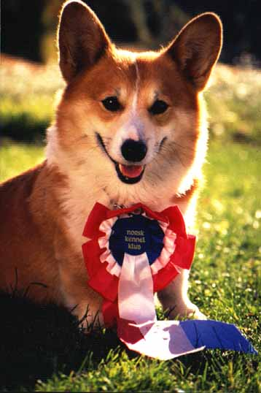
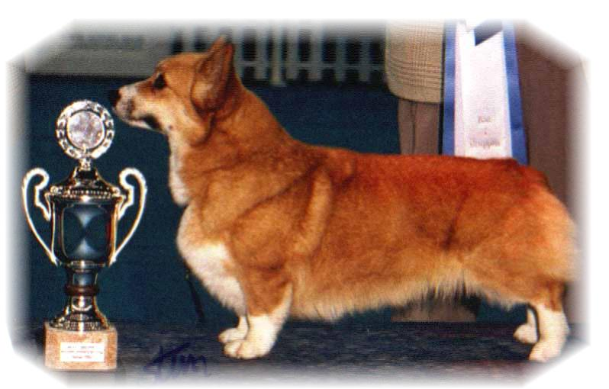

PARENTS |  | GRAND PARENTS |  | GREAT GRAND PARENTS |  | GREAT GREAT GRAND PARENTS
SIRE | MULTI BISS, INT,GB,MULTI CH WW08,EUW11  ANDVOL YA TVOY KUMIR | SIRE | INT CH  ERMYN CRANBERRY FROST | SIRE | MULTI BISS GB CH  ERMYN WING AND A PRAYER | SIRE | BISS, GB CH FOXYDALE SMART GUY
 |  |  |  |  |  | DAM | ERMYN STAR PERFORMER
 |  |  |  | DAM | INT CH  JANJINKS NOONDAY STAR AT ERMYN | SIRE | ROMX MULTI BISS GB CH  NINACORTE STARCASTER OF WOODHENGE
 |  |  |  |  |  | DAM | ERMYN MOONLIGHT ROMANCE AT JANJINKS
SIRE | MULTI BISS, INT,GB,MULTI CH WW08,EUW11  ANDVOL YA TVOY KUMIR | DAM | INT CH  ANDVOL KOROLEVA M,ARGO | SIRE | RUS CH  ANDVOL ZOLOTOY OSCAR | SIRE | FEDINA’S TAKE AND TOUCH
 |  |  |  |  |  | DAM | CH SVARZEKOKS I’M YOUR IDOL
 |  |  |  | DAM | ANDVOL EMILI (NBT) | SIRE | ALLIMAC’S KALA HARI (NBT)
 |  |  |  |  |  | DAM | RUS CH SARMEN DRASTIC
DAM | SIGGEN’S ANOTHER CHANCE | SIRE | MULTI BISS, INT, MULTI CH, EUW15  ANNLINE’S MY WAYS CHANCE | SIRE | INT.MULTI CH  CRAIGYCOR RUM PUNCH | SIRE | ROMX,MULTI BISS,US GR CH  TALLYRAND NO GREATER LOVE
 |  |  |  |  |  | DAM | IRL CH  SHAVALS FIRE VISION AT CRAIGYCOR
 |  |  |  | DAM | FIN CH  DWYNELLA KIWI CHANCE FOR ANNLINE | SIRE | NZ CH DWYNELLA PRINCE CHARMER
 |  |  |  |  |  | DAM | NZ CH DWYNELLA LOVE N’CHANCE
DAM | SIGGEN’S ANOTHER CHANCE | DAM | INT. NORD CH AMSTERDAM W 14 BENELUX W 14  SIGGEN’S STELLA POLARIS | SIRE | MULTI BISS, US GR CH  TALLYRAND HALO CHASER | SIRE | ROMX US GR CH ABERLEE BRANDSBY
 |  |  |  |  |  | DAM | TALLYRAND DEVOTED TO YOU
 |  |  |  | DAM | INT.NORD CH NORDW 10, DKW 11  SIGGEN’S HAZEL (NBT) | SIRE | INT.SE,EE CH CUUCHIN ASPENGLOW
 |  |  |  |  |  | DAM | INT.NORD.CH WW10.WWV11MULTI W.  SIGGEN’S UPTOWN GIRL (NBT)

Rita & Leif Herman Wilberg, Julie Wilberg Brandvik
Blåkollstubben 27,21, 1921 Sørumsand, NORWAY
Tlf : +47 97027566, +47 90084320, +47 97763827
Email : leif.herman@wilberg.info rita@wilberg.info julie_wilberg@hotmail.com
www.kennelsiggen.com

PEDIGREE OF: SIGGEN’S M-KULL 19 COLOUR, MARKINGS, TAILS: H:
DATE OF BIRTH: 28.04.2019 SEX:

