
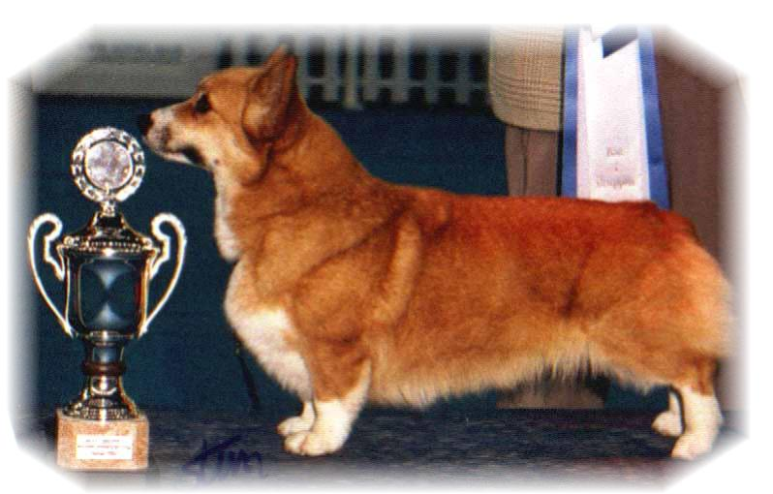

PARENTS |  | GRAND PARENTS |  | GREAT GRAND PARENTS |  | GREAT GREAT GRAND PARENTS
SIRE | CIB.NORD.CH BISS SEW-17, DKW-17, EUW-16. BEW-16. BE.NE.LUXW-16.  ANDVOL MARSHAL  RKF4238309 | SIRE | RUS.LIT.UKR.CH  SALVENIK SAIL AWAY | SIRE | GB CH  ROSEWOOD SET SAIL TO SALVENIK | SIRE | US CH TWINAN ANOTHER CHANCE FOR SALVENIK
 |  |  |  |  |  | DAM | ROSEWOOD BREEZE’N BY
 |  |  |  | DAM | SALVENIK STAR PERFORMER | SIRE | GB CH TWINAN COSTOM MADE
 |  |  |  |  |  | DAM | SALVENIK STARS IN YOUR EYES
SIRE |  | DAM | CIB CH  SIGGEN’S QUALITY BLACK PEARL | SIRE | GB.CIB.MULTI CH WW08, EUW11 MULTI BISS ANDVOL YA TVOY KUMIR | SIRE | CIB MULTI CH ERMYN CRANBERRY FROST
 |  |  |  |  |  | DAM | RUS CH EUJW ANDVOL KOROLEVA MARGO
 |  |  |  | DAM | CIB NORD CH BISS DKW-11. NORDW-10 SIGGEN’S HAZEL | SIRE | AUS CIB SE EE CH CUUCHIN ASPENGLOW
 |  |  |  |  |  | DAM | CIB NORD CH BISS WW-10, WWV-11NORD.V-11,NORD.WV-11,NWV-11,12. NV-04, SV-04,05. EUV-06. SIGGEN’S UPTOWN GIRL
DAM | NO CH BISS  SIGGEN’S GRACE KELLY  NO42433/17 | SIRE | CIB MULTI CH WW13 EUW BISS  ANDVOL MERCURY | SIRE | RUS LT CH  KINSALE STAR TREAT | SIRE | US CH LLANDIANS STORM CATCHER
 |  |  |  |  |  | DAM | CH KINSALE MIDNIGHT MAGIC
 |  |  |  | DAM | CIB MULTI CH BISS  ANDVOL NINA RICCI | SIRE | RUS SK CH TWINAN GOLD SOVEREIGN
 |  |  |  |  |  | DAM | ANFISA HAUS DANDO
DAM | NO CH BISS  SIGGEN’S GRACE KELLY  NO42433/17 | DAM | O CH  SIGGEN’S SPRING FLING | SIRE | US CH MULTI BISS TALLYRAND HALO CHASER | SIRE | US CH BISS ABERLEE BRANDSBY
 |  |  |  |  |  | DAM | TALLYRAND DEVOTED TO YOU
 |  |  |  | DAM | INT NORD CH BISS DKW11 NORDW10 NOVW16 SIGGEN’S HAZEL | SIRE | AUS CIB SE EE CH CUUCHIN ASPENGLOW
 |  |  |  |  |  | DAM | CIB NORD CH BISS WW10 WWV11 MULTI W SIGGEN’S UPTOWN GIRL

Rita & Leif Herman Wilberg, Julie Wilberg Brandvik
Blåkollstubben 27,21, PB : 144
1921 Sørumsand, NORWAY
Tlf : +47 97027566, +47 90084320, +47 97763827
Email : leif.herman@wilberg.info rita@wilberg.info julie_wilberg@hotmail.com
www.kennelsiggen.com

PEDIGREE OF: SIGGEN’S N-KULL COLOUR, MARKINGS, TAILS:
DATE OF BIRTH: 16.01.2020 SEX:

