
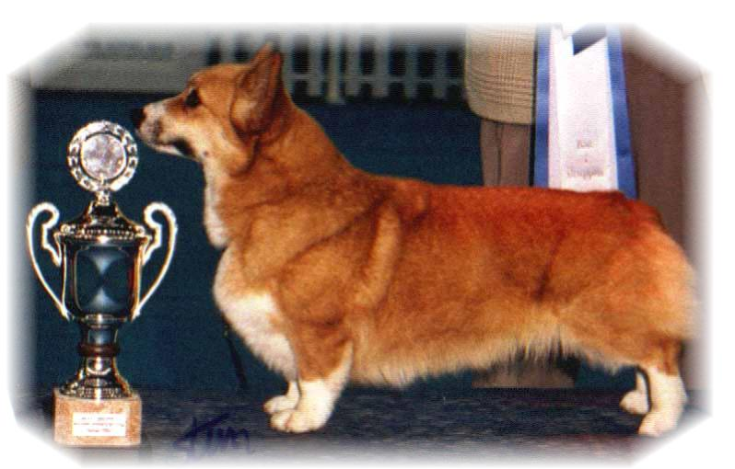

 |  | GRAND PARENTS |  | GREAT GRAND PARENTS |  | GREAT GREAT GRAND PARENTS
SIRE | N.SE.U.CH.SJW18.AUJW19.  SIGGEN’S ILLUMINATOR  NO38130/18 | SIRE | BISS CIB.NORD CH NW15 NORDW15  SIGGEN’S PUSJKIN | SIRE | MULTI BISS.GB.CIB.MULTI CH WW08.EUW11  ANDVOL YA TVOY KUMIR | SIRE | MULTI CH ERMYN CRANBERRY FROST
 |  |  |  |  |  | DAM | RUS CH ANDVOL KOROLEVA MARGO
 |  |  |  | DAM | NO CH  SIGGEN’S JOZZE-FINFIN | SIRE | CIB.MULTI CH WW09  NEBRIOWA COLE HAAN
 |  |  |  |  |  | DAM | NO.SE CH SIGGEN’S ELLE VILLE
SIRE | N.SE.U.CH.SJW18.AUJW19.  SIGGEN’S ILLUMINATOR  NO38130/18 | DAM | AUST SUP. CIB.NORD. CH NW17.DKW17.NORDW17 BISS  BOJOJAMILE BEHIND THE NEWS | SIRE | AUST GR CH  BOJOJAMILE BEAN SERIOUS | SIRE | US.CA CH STONECROFT SECOND SIGHT
 |  |  |  |  |  | DAM | AUST CH BOJOJAMILE BIVIAN LEIGH
 |  |  |  | DAM | AUST CH  BOJOJAMILE BEHIND CLOSED DOORS | SIRE | AUST CH BOJOJAMILE BORN TO BE WILD
 |  |  |  |  |  | DAM | AUST CH BOJOJAMILE BEHIND THE SCENES
DAM | NO.SE CH  SIGGEN’S CANDY | SIRE | WW-EW. CIB.RUS.IT CH BISS  ANDVOL MERCURY | SIRE | RUS.LT CH  KINSALE STAR TREAT | SIRE | USA.UAR CH  LLANDIANS STORM CATCHER
 |  |  |  |  |  | DAM | UAR CH  KINSALE MIDNIGHT MAGIC
 |  |  |  | DAM | EW.CIB.RUS.IRL.FIN CH  ANDVOL NINA RICCI | SIRE | RUS.SLO.POL.CH  TWINAN GOLD SOVEREIGN
 |  |  |  |  |  | DAM | ANFISA HAUS DANDO
DAM | NO.SE CH  SIGGEN’S CANDY | DAM | INT.NORD CH MULTI BISS  SIGGEN’S QUEEN OF DIAMONDS | SIRE | MULTI BISS.GB.CIB.MULTI CH WW08.EUW11  ANDVOL YA TVOY KUMIR | SIRE | MULTI CH ERMYN CRANBERRY FROST
 |  |  |  |  |  | DAM | RUS CH ANDVOL KORLEVA MARGO
 |  |  |  | DAM | BISS INT.NORD CH NORDW 10  SIGGEN’S HAZEL | SIRE | INT.AUST.EE.SE CH CUUCHIN ASPENGLOW
 |  |  |  |  |  | DAM | INT.NORD CH MULTI BISS MULTI W  SIGGEN’S UPTOWN GIRL

Rita & Leif Herman Wilberg, Julie Wilberg Brandvik
Blåkollstubben 27,21, PB : 144
1921 Sørumsand, NORWAY
Tlf : +47 97027566, +47 90084320, +47 97763827
Email : leif.herman@wilberg.info rita@wilberg.info julie_wilberg@hotmail.com
www.kennelsiggen.com

PEDIGREE OF: SIGGEN’S O-KULL 20 COLOR AND MARKINGS:
BORN: 28.02.2020 SEX:

