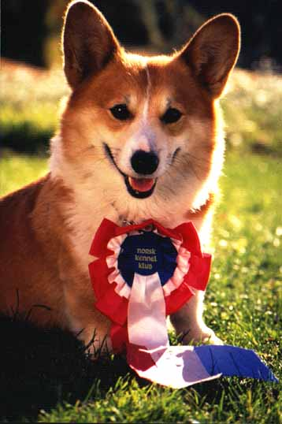
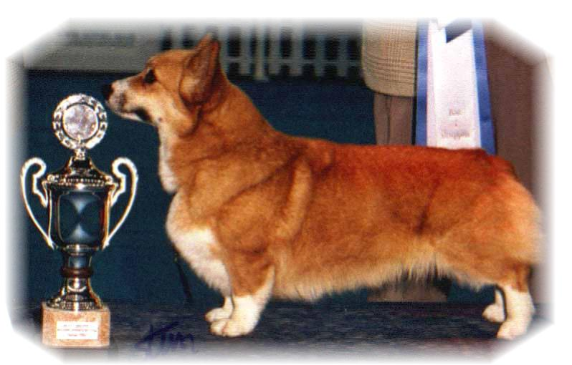

PARENTS |  | GRAND PARENTS |  | GREAT GRAND PARENTS |  | GREAT GREAT GRAND PARENTS
SIRE | NJV19, NV20  SIGGEN’S LIQUORICE (FULLCERTET)  NO36603/19 | SIRE | CIB.NO.SE.SI.BA.RS.HR CH. NORDW-18. BISS  SIGGEN’S GREAT GATSBY | SIRE | WW.EW.CIB.RU.IT.CH BISS  ANDVOL MERCURY | SIRE | RU.LT.CH KINSALE STAR TREAT
 |  |  |  |  |  | DAM | INT.RU.LT.UA.HR.CH ANDVOL NINA RICCI
 |  |  |  | DAM | NCH  SIGGEN’S SPRING FLING | SIRE | US.GR.CH BISS.TALLYRAND HALO CHASER
 |  |  |  |  |  | DAM | CIB.NORD.CH.MULTI.W.BISS SIGGEN’S HAZEL
SIRE | NJV19, NV20  SIGGEN’S LIQUORICE (FULLCERTET)  NO36603/19 | DAM | GB.NORD.CIB.U.CH.WW-17. JWW-13. DKV-13, 14. SEV-13,14. NV-14..NORDV-14 .BISS  SIGGEN’S QUEEN OF SPADES | SIRE | WW.EW.GB.MULTI CH .MULTI BISS  ANDVOL YA TVOY KUMIR | SIRE | CIB.MULTI CH ERMYN CRANBERRY FROST
 |  |  |  |  |  | DAM | RU.CH ANDVOL KOROLEVA MARGO
 |  |  |  | DAM | DKW-11. NORD.V-10. NVV18 N.SE.DK.NORD.CIB.CH. BISS  SIGGEN’ S HAZEL | SIRE | CIB.AUS.SE.EE.CH CUUCHIN ASPENGLOW
 |  |  |  |  |  | DAM | CIB.NORD.CH.MULTI W. BISS  SIGGEN’S UPTOWN GIRL
DAM | CIB.MULTI.CH  SIGGEN’S XTRAORDINARY  NO30090/15 | SIRE | CIB.NORD.CH MULTI W BISS  SIGGEN’S PUSJKIN | SIRE | WW.EW.GB.MULTI CH .MULTI BISS  ANDVOL YA TVOY KUMIR | SIRE | CIB.MULTI CH ERMYN CRANBERRY FROST
 |  |  |  |  |  | DAM | RU.CH ANDVOL KOROLEVA MARGO
 |  |  |  | DAM | NORD.CH  SIGGEN’S JOZZE-FIFIN | SIRE | CIB.US.EE.SE.CH WW09 NEBRIOWA COLE HAAN
 |  |  |  |  |  | DAM | NO.SE CH SIGGEN’S ELLE VILLE
DAM | CIB.MULTI.CH  SIGGEN’S XTRAORDINARY  NO30090/15 | DAM | CIB.NORD.LUX CH NV11 BISS  CIMAITH‘S ELEGANT SIGGEN DESIGN | SIRE | GB.CIB.NORD CH MULTI W BISS SIGGEN’S DOFFEN | SIRE | US.INT.NORD.CH MULTI W SIGGEN’S YASSIR
 |  |  |  |  |  | DAM | INT.SE.EE.CH OTREKS NORTHERN STAR
 |  |  |  | DAM | AUS.INT.SE.LUX CH WW08.WWV12  CUUCHIN BORN TO ENCHANT | SIRE | AUS CH CUUCHIN SUPERSTAR
 |  |  |  |  |  | DAM | AUS CH CUUCHIN BORN T BEWICH

Rita & Leif Herman Wilberg, Julie Wilberg Brandvik
Blåkollstubben 27,21, PB : 144
1921 Sørumsand, NORWAY
Tlf : +47 97027566, +47 90084320, +47 97763827
Email : leif.herman@wilberg.info rita@wilberg.info julie_wilberg@hotmail.com
www.kennelsiggen.com

PEDIGREE OF: SIGGEN’S P-KULL 20 COLOUR, MARKINGS, TAILS:
DATE OF BIRTH: 22.07.2020 SEX:

