
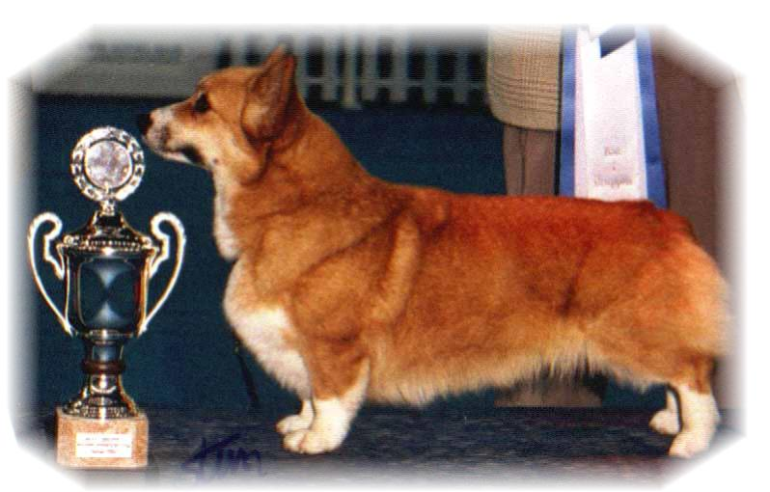

PARENTS |  | GRAND PARENTS |  | GREAT GRAND PARENTS |  | GREAT GREAT GRAND PARENTS
SIRE | NORD.CH  PEMLAND MOONLIGHT | SIRE | BELROYD DRAGONFLY | SIRE | GB.CH  CORDACH TRIBUNE | SIRE | CORDACH SUPERMEX
 |  |  |  |  |  | DAM | CORDACH KERI
 |  |  |  | DAM | BELROYD WOOD CHAT | SIRE | GB.CH BELROYD NUTCRACKER
 |  |  |  |  |  | DAM | GB.CH BELROYD SHORE LARK
SIRE | NORD.CH  PEMLAND MOONLIGHT | DAM | PEMLAND LADY OF NIGHT | SIRE | GB.CH  BANNALYNE ROYAL EDITION OF RIVONA | SIRE | GB.CH BLANDS LIMITED EDITION
 |  |  |  |  |  | DAM | ELEGANCE AT BANNALYNE
 |  |  |  | DAM | FITZDOWN MISTY CORAL OF PEMLAND | SIRE | GB.CH SUPERGUY OF PEMLAND
 |  |  |  |  |  | DAM | PEARL SPRAY OF FITZDOWN
 | N.S.CH  SIGGEN’S LICKETY SPLIT | SIRE | Int, Nord, S, N, Dk, Lux, D, VHD, A, Ch, F u ch  EUW - 97, KBHV - 97, NV - 98  SIGGEN’S JEREMY | SIRE | N.CH  STOMPEN’S HERMAN | SIRE | INT.NORD.CH BLANDS GAMBLIN’ MAN
 |  |  |  |  |  | DAM | MALSIS SWEET GIRL
 |  |  |  | DAM | Int Nord S.N.Dk Ch NV91,92,97,99.SV93,94,NordV94 BrysselW95. EUV 97.KBHV 97 SIGGEN’S CONNY | SIRE | KAYTOP DREAM OF DELIGHT
 |  |  |  |  |  | DAM | INT.N.S.CH NV 90 SIGGEN’S VICTORIA
 | N.S.CH  SIGGEN’S LICKETY SPLIT | DAM | CARILLO WHIRL WIND | SIRE | INT.NORD CH.NORDV 87, NV 88,89  SIGGEN’S VANCO | SIRE | INT NORD.CH BLANDS GAMBLIN’ MAN
 |  |  |  |  |  | DAM | N.S.CH NORDV 84 SIGGEN’S KIKKI
 |  |  |  | DAM | N.S.CH  CARILLO WICH WITCH | SIRE | KARWIN’S ROCKY
 |  |  |  |  |  | DAM | CARILLO WINDWOOD BEAUTY
PEDIGREE OF : | SIGGEN’S R-KULL |  | COLOUR AND MARKINGS :
DATE OF BIRTH : | 09.09.2000 |  | SEX :
Rita & Leif Herman Wilberg
Blåkollstubben 27, PB : 158
1921 Sørumsand
Tlf : +47 63 82 61 17 (Private)
Fax : +47 63 82 70 89
Email : kesiggen@online.no
www.kennelsiggen.com

