
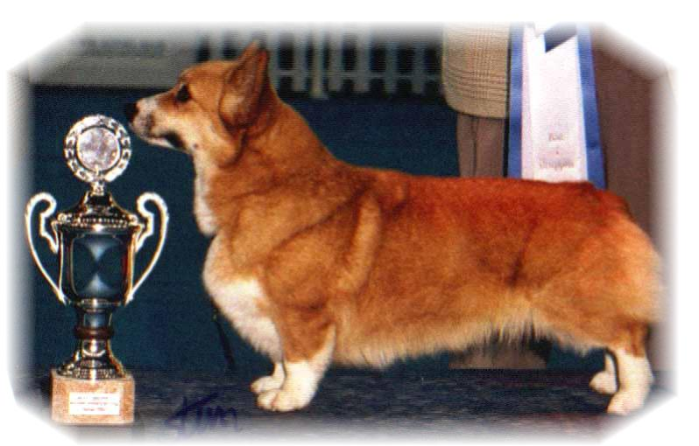

PARENTS |  | GRAND PARENTS |  | GREAT GRAND PARENTS |  | GREAT GREAT GRAND PARENTS
SIRE | INT.NORD.P.AUST.CH  NV00.01.02.05 SV01,VV01, NORDV 02  SIGGEN’S OBERON | SIRE | USA.MULTI.CH MULTI.V  ANNLINE’S WELL DONE | SIRE | SF.EST.CH  KILVEWOOD OCTOBER MIST | SIRE | THE CHARMER OF KILVEWOOD
 |  |  |  |  |  | DAM | KILVEWOOD SILVER CHARM
 |  |  |  | DAM | ANNLINE’S QUEEN OF WISHES | SIRE | INT.DK.SF.CH TUULANTEI REMU
 |  |  |  |  |  | DAM | S.SF.EST.CH ANNLINE’S GOLDEN WISH
SIRE |  | DAM | N.S.CH  SIGGEN’S LICKETY SPLIT | SIRE | INT.MULTI.CH.MULTI.V  SIGGEN’S JEREMY | SIRE | N.CH STOMPEN’S HERMAN
 |  |  |  |  |  | DAM | INT.MULTI.CH.MULTI.V SIGGEN’S CONNY
 |  |  |  | DAM | CARILLO WHIRL WIND | SIRE | INT.NORD CH.NORDV 87, NV 88,89  SIGGEN’S VANCO
 |  |  |  |  |  | DAM | N.S.CH CARILLO WICH WITCH
DAM | USA.CH  OTREKS SPECIAL TRADITION | SIRE | USA.CH  SHAVALS FIRE MASTER | SIRE | GB.CH  WOODHENGE STAR VOYAGER | SIRE | GB.CH  BLANDS LIMITED EDITION OF BELROYD
 |  |  |  |  |  | DAM | WOODHENGE BLACK VELVET
 |  |  |  | DAM | BELROYD THE ADVOCAT AT SHAVALS | SIRE | GB.CH BELROYD NUTCRACKER
 |  |  |  |  |  | DAM | BEROYD POPINJAY
DAM | USA.CH  OTREKS SPECIAL TRADITION | DAM | OTREKS ABBOT CHARACTER | SIRE | USA.CH  OTREKS HERMAN JOSEPH | SIRE | LARKLAINS MASTER CAMEO
 |  |  |  |  |  | DAM | USA.CH OTREKS CHINA GOLD
 |  |  |  | DAM | OLANTIGH EXTRA SPECIAL | SIRE | GB.CH FITZDOWN DORIAN OF DEAVITTE
 |  |  |  |  |  | DAM | OLANTIGH FACINATION
PEDIGREE OF : | SIGGEN’S S-KULL |  | COLOUR AND MARKINGS :
DATE OF BIRTH : | 29.06.2001 |  | SEX :
Rita & Leif Herman Wilberg
Blåkollstubben 27, PB : 158
1921 Sørumsand
Tlf : +47 63 82 61 17 (Private)
Fax : +47 63 82 70 89
Email : kesiggen@online.no
www.kennelsiggen.com

