
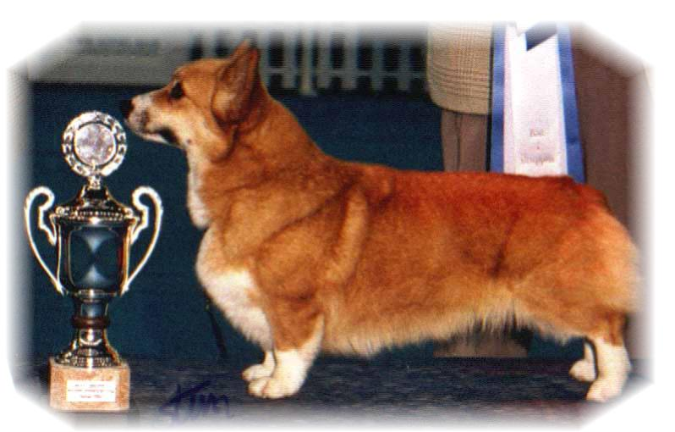

PARENTS |  | GRAND PARENTS |  | GREAT GRAND PARENTS |  | GREAT GREAT GRAND PARENTS
SIRE | Siggen’s Prikken | SIRE | Kimber | SIRE | N.ch Borgatun’s Yves | SIRE | Int Nord.ch Blands Gamblin’ Man
 |  |  |  |  |  | DAM | Int.N.S.ch Borgatun’s Urchin
 |  |  |  | DAM | N.ch Joy for Jessika | SIRE | Gb.ch.NV94 Perrymist Red Adair
 |  |  |  |  |  | DAM | N.ch Irish Fog
SIRE | Siggen’s Prikken | DAM | Int.Nord.ch Siggen’s Jessika | SIRE | N.ch Stompen’s Herman | SIRE | Int.Nord. ch Blands Gamblin’ Man
 |  |  |  |  |  | DAM | Malsis Sweet Girl
 |  |  |  | DAM | Inr.Nord.ch.NV91,92,97,99, SV93,94, NordV94, EuV97  Siggen’s Conny | SIRE | Kaytop Dream of Delight
 |  |  |  |  |  | DAM | Int.N.S.ch NV 90Siggen’s Victoria
DAM | N.S.ch Siggen’s Roxy Music | SIRE | Nord.ch Pemland Moonlight | SIRE | Belroyd Dragonfly | SIRE | Gb.ch Cordach Tribune
 |  |  |  |  |  | DAM | Belroyd Wood Chat
 |  |  |  | DAM | Pemland Lady of Night | SIRE | Gb.ch Bannalyne Royal Edition of Rivona
 |  |  |  |  |  | DAM | Fitzdown Misty Coral of Pemland
DAM | N.S.ch Siggen’s Roxy Music | DAM | N.S.ch Siggen’s Lickety Split | SIRE | Int.Nord.D.Ch.F.Lux.A.ch  Siggen’s Jeremy | SIRE | N.ch Stompen’s Herman
 |  |  |  |  |  | DAM | Int.Nord.ch NV 91,92,97,99, SV93,94,EuV97
 |  |  |  | DAM | Carillo Whirl Wind | SIRE | Int.N.S.ch NV88,89, NordV87Siggen’s Vanco
 |  |  |  |  |  | DAM | N.S.ch Carillo Wich Witch
Rita & Leif Herman Wilberg
Blåkollstubben 27, PB : 158
1921 Sørumsand
Tlf : +47 63 82 61 17 (Private)
: +47 63 82 72 54 (Work )
Fax : +47 63 82 70 89
Email : kesiggen@online.no

PEDIGREE OF : | Siggen’s V-Kull |  | COLOUR AND MARKINGS :
DATE OF BIRTH : | 29.11.2004 |  | SEX : | 3+1

