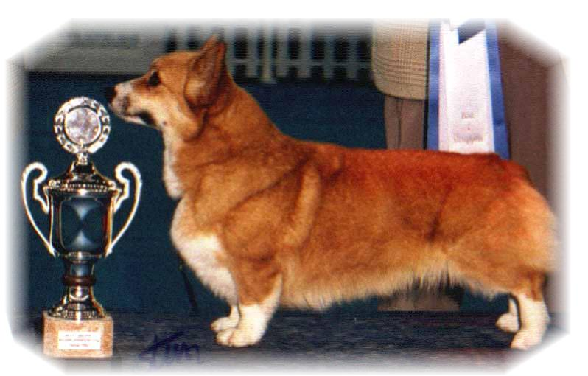
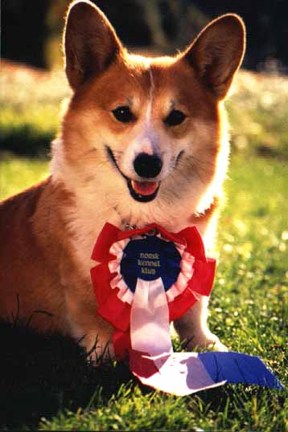
PARENTS |  | GRAND PARENTS |  | GREAT GRAND PARENTS |  | GREAT GREAT GRAND PARENTS
SIRE | NORD.CH  SIGGEN’S PUSJKIN | SIRE | INT.GB.MULTI.CH WW08,EUW11  ANDVOL YA TVOY KUMIR | SIRE | RUS.CH  ERMYN CRANBERRY FROST | SIRE | GB.CH ERMYN WING AND A PRAYER
 |  |  |  |  |  | DAM | JANJINKS NOONDAY STAR AT ERMYN
 |  |  |  | DAM | ANDVOL KOROLEVA MARGO | SIRE | ANDVOL ZOLOTOY OSCAR
 |  |  |  |  |  | DAM | ANDVOL EMILI
 |  | DAM | INT.NO.SE.CH  SIGGEN’S JOZZE-FINFIN | SIRE | INT.US.SE.EE.CH WW09  NEBRIOWA COLE HAAN | SIRE | US.CH  FERGWYN NOW WOYAGER
 |  |  |  |  |  | DAM | US.CH NEBRIOWA HELLO GOOD LOOKING
 |  |  |  | DAM | NO.SE.CH  SIGGEN’S ELLE VILLE | SIRE | SE.CH SIGGEN’S DOOLEY
 |  |  |  |  |  | DAM | INT.NORD.CH WW10, VWW11.EUW06.NV04 SV04,05.NORDV11.NORDVV11.NVV11,12  SIGGEN’S UPTOWN GIRL
DAM | INT.NORD.CH LUX.CH. NV-11  CIMAITH’S ELEGANT SIGGEN DESIGN | SIRE | GB.INT. U.CH. NV-07, SV-08  SIGGEN’S DOFFEN | SIRE | US.INT.NORD.U.CH.  NV-08,NV-10  SIGGEN’S YASSIR | SIRE | INT.CH CRAIGYCOR RUM PUNCH
 |  |  |  |  |  | DAM | NO.SE.CH SIGGEN’S ROXY MUSIC
 |  |  |  | DAM | FRW-12. INT.SE.EE.U.CH. OTREKS NORTHERN STAR | SIRE | US.CH PENTALAR PRINCE HARRI
 |  |  |  |  |  | DAM | OTREKS FOOLISH DESIGN
 |  | DAM | AUST. SE. INT. LUX CH. SV-08  WW-08, VWW-12  CUUCHIN BORN TO ENCHANT | SIRE | AUST.CH.  CUUCHIN SUPERSTAR | SIRE | AUST CH ABERLEE STAR SEQUENZE
 |  |  |  |  |  | DAM | KEVLAIN KRISTA
 |  |  |  | DAM | AUST.CH.  CUUCHIN BORN T BEWITCH | SIRE | AUST.CH CUUCHIN BORN T PERFOR
 |  |  |  |  |  | DAM | AUST CH ANTUDOR BEWITCHED
PEDIGREE OF : | Siggen’s X-kull |  | COLOUR AND MARKINGS :
DATE OF BIRTH : | 19.11.2014 |  | SEX :
Rita & Leif Herman Wilberg
Blåkollstubben 27, PB : 158
1921 Sørumsand
Tlf : +47 63 82 61 17 (Private)
Fax : +47 63 82 70 89
Email : kesiggen@online.no
www.kennelsiggen.com

